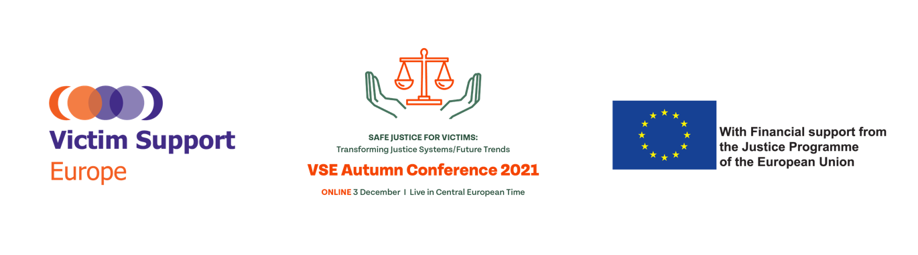

3 December 2021, 10.00 – 18.00 (CET)
Held: online in Zoom

Tasks – staff

3 Dec | Assign co-hosts, speakers + participants | AV team, Lieselotte, Keti
 | Make sure to do screenshots - attendance sheets | AV
 | Take Notes | Iris, Sasha, Solène, Pam
 | Social media | Lieselotte
 | Keep time of speakers | Léa
 | Create whatsapp group | Léa
 | Create poll for the live debate | AV company
 | Polls for sessions | Sigal +team
 | Create networking rooms | AV company
 | Reply to zoom chat messages | Ruth, Annelies, Sigal, Aleks
 | Ppts demonstration | Marina, Lieselotte
 | Assign co-hosts, speakers + participants | AV team, Lieselotte, Keti

SCENOGRAPHY

10:00 -10:00  10 sec | Video intro
10:00 – 10:05  5min | Welcome speech Geraldine Hanna, President of Victim Support Europe
10:05 – 10:10 | Introduction speaker Levent
10:10 – 10.15  10min | Welcoming Remarks: Didier Reynders (pre-recorded)
 | Introduction speaker Levent
10:15 – 10:20  5min | Opening speech: Richard Sonnenschein, Acting Director of Criminal Justice, European Commission
 | Introduction speaker Levent
10:25 – 10:35  10min | Live Testimony: Nina Fuchs, Survivor of sexual assault

Part 1: Safe reporting as the first step in seeking justice
10:35-10:55  20min  Speaker Presentation | Levent Altan: Defining ‘Safe justice for victims’
10:55-10:56 | Levent connects his speech to the next one - Nikolett Szelei, Researcher, Ghent University - How to ensure safe reporting for migrant victims of sexual violence? A framework for policy and practice
10.56 - 11.15  20min  Speaker presentation | Presentation: Nikolett Szelei, Researcher, Ghent University
11.15 - 11.15 | Levent connects the speech of Nikolett Szelei to the next one – Aleš Gião Hanek, Hate Crime Officer, OSCE Office for Democratic Institutions and Human Rights – Under-reporting of hate crime: why is it a problem and what can be done about it?
11:15 - 11.35  20min  Speaker Presentation | Presentation: Aleš Gião Hanek, Hate Crime Officer, ODIHR
11:35 – 11:35 | Levent connects the speech of Aleš Gião Hanek to the next one – Aleksandra Anikina, Communications Officer, HEUNI - Research to Action: Overcoming the Challenges of Underreporting Together with the Victims and Practitioners
11:35 – 11:55  20min  Speaker Presentation | Presentation: Aleksandra Anikina, Communications Officer, HEUNI
11:55 – 11:55 | Conclusions by Levent Altan. Levent introduces the coffee break.
11:55 – 12:30 | Coffee break - slide with the logo of the conference + QR code
Part 2: Modern solutions to effectively support victims in criminal proceedings
12:30 – 12:30 | Levent introduces Part 2 and the presentation of Suzan van der Aa Professor in Criminal Law and Criminal Procedure, Maastricht University - A critical break down of EU justice systems
12:30- 12:50  20min  Speaker Presentation | Presentation: Suzan van der Aa, Professor in Criminal Law and Criminal Procedure, Maastricht University
12:50 – 13:30  40min  Panel Discussion | Levent connects the presentation of Suzan van der Aa to next one - the panel discussion on modern solutions to support victims at court
13:30 – 13:30 | Levent conclusions and introduces lunch break
13:30 – 14:30 | Lunch Break – slide with the logo of the conference+QR code
PART 2: Modern solutions to effectively support victims in criminal proceedings (continuation)
14:30 – 14:30 | Levent introduces the continuation of Part 2 and the testimonials of Philippe Vandenberghe and Florian Jehin
14:30 – 14:45  15min  Speaker Presentation | Live testimony: Philippe Vandenberghe & Florian Jehin
14 :45 – 14 :45 | Levent connects testimony Phillipe & Florian to the next presentation - Pauline Okroglic, Legal Officer – Victim Support and European Affairs, France Victimes
14:45 – 15:05  20min  Speaker Presentation | Presentation: Pauline Okroglic, Legal Officer – Victim Support and European Affairs, France Victimes
15:05 – 15:35  30min  Panel Discussion | Levent connects the presentation of Pauline Okroglic to next one - Effective communication and information sharing mechanisms within criminal justice system
PART 3: Collaborative working to achieve better justice for victims
15:35 – 15:35 | Levent connects panel discussion to the next part of the conference, starting with the presentation of Jérôme Moreau
15:35 – 15:55  20min  Speaker Presentation | Presentation: Jérôme Moreau, President, “Association Nivernaise d’Aide aux Victimes d´Infractions” and Vice-President, France Victimes and Victim Support Europe
15:55 – 15:55 | Levent connects the speech of Jérôme Moreau to the next one – Mónica Martí García, Senior Project Manager – Programmes Unit, EJTN - Judicial Training on Victims’ Rights in the EU in practice: The role of the European Judicial Training Network
15:55 – 16:15  20 min  Speaker Presentation | Presentation: Mónica Martí García, Senior Project Manager – Programmes Unit, European Judicial Training Network (EJTN)
16:15 – 16:15 | Levent connects the speech of Mónica Martí García to the next one – Elisabeth Zinschitz, Head of Sector – CEPOL Knowledge Centres- The importance of training of European law enforcement on safe justice
16:15 – 16:35  20min  Speaker Presentation | Presentation: Elisabeth Zinschitz, Head of Sector – CEPOL Knowledge Centres - The importance of training of European law enforcement on safe justice
16:35 – 16:35 | Conclusions by Levent Altan. Levent introduces the coffee break.
16:35 – 16:55 | Coffee break - slide with the logo of the conference + QR code
PART 4: Live debate “What can we do to make the criminal justice system work better?”
16:55 – 16:55 | Levent introduces the final part
16:55 – 17:45  50min  Live Debate | Live debate: “What can we do to make the criminal justice system work better?”  Moderator: Suzan van der Aa  Speaker participants: Nikolett Szelei, Monica Marti-Garcia, Saar Baert  Poll: AV company  Suzan is introducing POLL #3 at the beginning of her session.
17:45:17:45 | Levent conclusions
17: 45 – 18:00  15min  Online Closing Speech | Closing of the main conference part by the Vice - President of VSE Petra Klein

