CIVIL SOCIETY REPORTING GUIDANCE AND TEMPLATE
GUIDANCE - Information we seek and publish
Currently, for each published incident, the following information is presented in a chart on the country page:

- INCIDENT CATEGORIZATION, consisting of (i) bias motivation, (ii) date (year, month) of incident, (iii) type of incident:

- An INCIDENT SUMMARY, which appears upon clicking Show info in the description column: 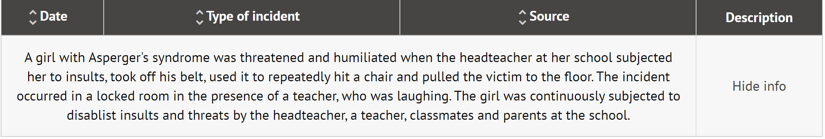

The format of published summary descriptions is standardized and we try to highlight the following information, if provided:
Type of information
- Course of attack – what happened, main circumstances (incl. where, type of violence, time of day) | - Bias indicators (facts that make it a hate incident)
- Victim/target properties – age, gender, other identity traits, type and affiliation of targeted property | - Victim(s) – sustained injuries or other harm
- Victim-perpetrator relationship (especially where there power relationship is involved such as teacher-student, father-daughter etc.) | - Number of perpetrators and their age, gender and other identity traits, if relevant
- Perpetrator’s affiliation with a hate group | - If the incident was committed by a group
- If the incident was committed by a representative of state authorities (e.g., police, border patrol) | - Use of weapon(s)
- Police were at the scene but failed to protect the victims | - If hate crime investigation (taking bias motivation into account) was initiated by the authorities
REPORTING TEMPLATE

ODIHR’s hate crime reporting team analyses each reported incident so you do not have to.
We can however only categorize and describe incidents correctly if sufficient information is provided. We do, therefore, appreciate receiving detailed information about each incident, covering as many aspects mentioned above as possible.

The template below aims to make your (and our) work easier. We will however continue receiving the incident information in whichever format you submit it!

* For ODIHR’s typology of bias indicators and other information, please consult the Factsheet.

Please download this file and use the table to report your incidents to ODIHR at tndinfo@odihr.pl by 30 April 2022
Date of incident | Country, location | Source | Incident description:  When, where, and how did the incident happen? | Bias indicators:*  Why is this a hate incident? | Additional information, comments
Provide the exact date of the incident.  If exact timing is not possible, please provide range of likely dates. | Country, city / town / village.  Include the region if necessary to avoid confusion (e.g., multiple villages with the same name). | Please mention how you learnt about the incident.  For example:  - from the media;  - from victim’s or witnesses’ testimony;  - from the police.  Provide a link to the original source(s), where possible. | Describe the incident as completely as possible based on the information available to you. | Please explain separately why you consider this to be a hate incident. Provide details, rather than categories or types of bias indicators. Mention any insults used and the context in which the incident occurred, for example:  - ‘Perpetrator called the victim a “filthy Krakozian” and demanded that all Krakozian parasites be kicked out of the country’.  - ‘Incident happened on the national day and was preceded by anti-migrant discourse in the media, with some politicians calling for violence.’  - ‘The park X is broadly known as a place frequented by LGBTI.’  - ‘Some of the attackers wore military fatigues and combat boots, two wore T-shirts with the number 88.”  You can leave this field empty if such details are already included in the preceding box (description). | You may wish to provide any additional observations you deem necessary for ODIHR’s correct interpretation of reported data. For example:  - ‘In our context, the ethnic and anti-migrant slurs used are broadly understood to encompass the religion as well.’  - ‘In the Bastillian dialect, ‘Krakozian’ is a pejorative term for people from the south of the country.’  - ‘We weren’t able to determine the scope of injuries of the older victim, as she left the scene and could not be located.’  - ‘We consider this as both gender-based and racist attack.’
Place for your information | Place for your information | Place for your information | Place for your information | Place for your information | Place for your information
Place for your information | Place for your information | Place for your information | Place for your information | Place for your information | Place for your information
Place for your information | Place for your information | Place for your information | Place for your information | Place for your information | Place for your information
Place for your information | Place for your information | Place for your information | Place for your information | Place for your information | Place for your information
Place for your information | Place for your information | Place for your information | Place for your information | Place for your information | Place for your information

